Step by step guide to accessing your zoom meeting with your physiotherapist.

Step 1:
10-15 minutes before your appointment, go to your email. You should have received an email from your physiotherapist. It should resemble the image below. Select the device you would like to conduct your meeting on click on the email. Click on the link highlighted in the image below.

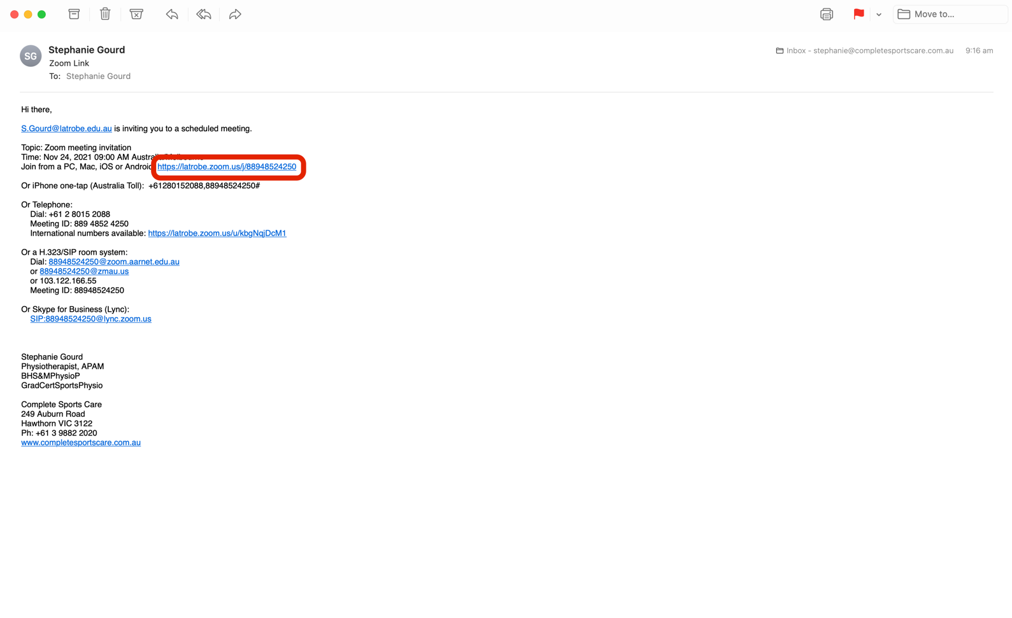

Step 2:
When you have clicked on this link, it will take you to your preferred internet browser and request that you access the meeting via zoom software. Click on the allow button in the video below. You do not need to have Zoom software or an account before clicking allow here.

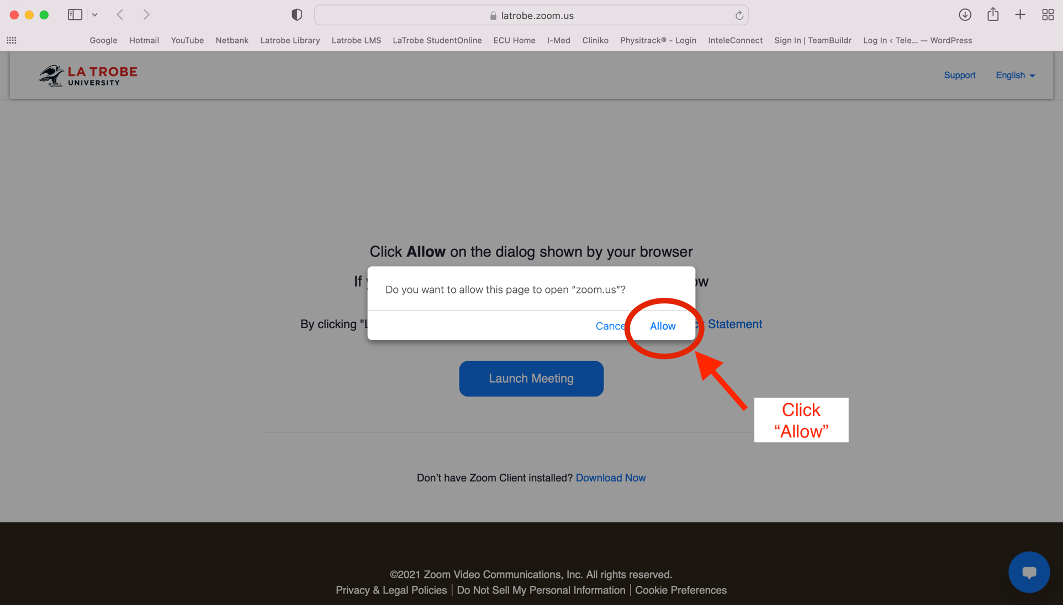

Step 3:
After clicking allow, your compute should take you to your zoom meeting, where you will see a screen that looks like the image below. Select the option to join with computer audio. This will mean that the sound will come through your computer sound system.

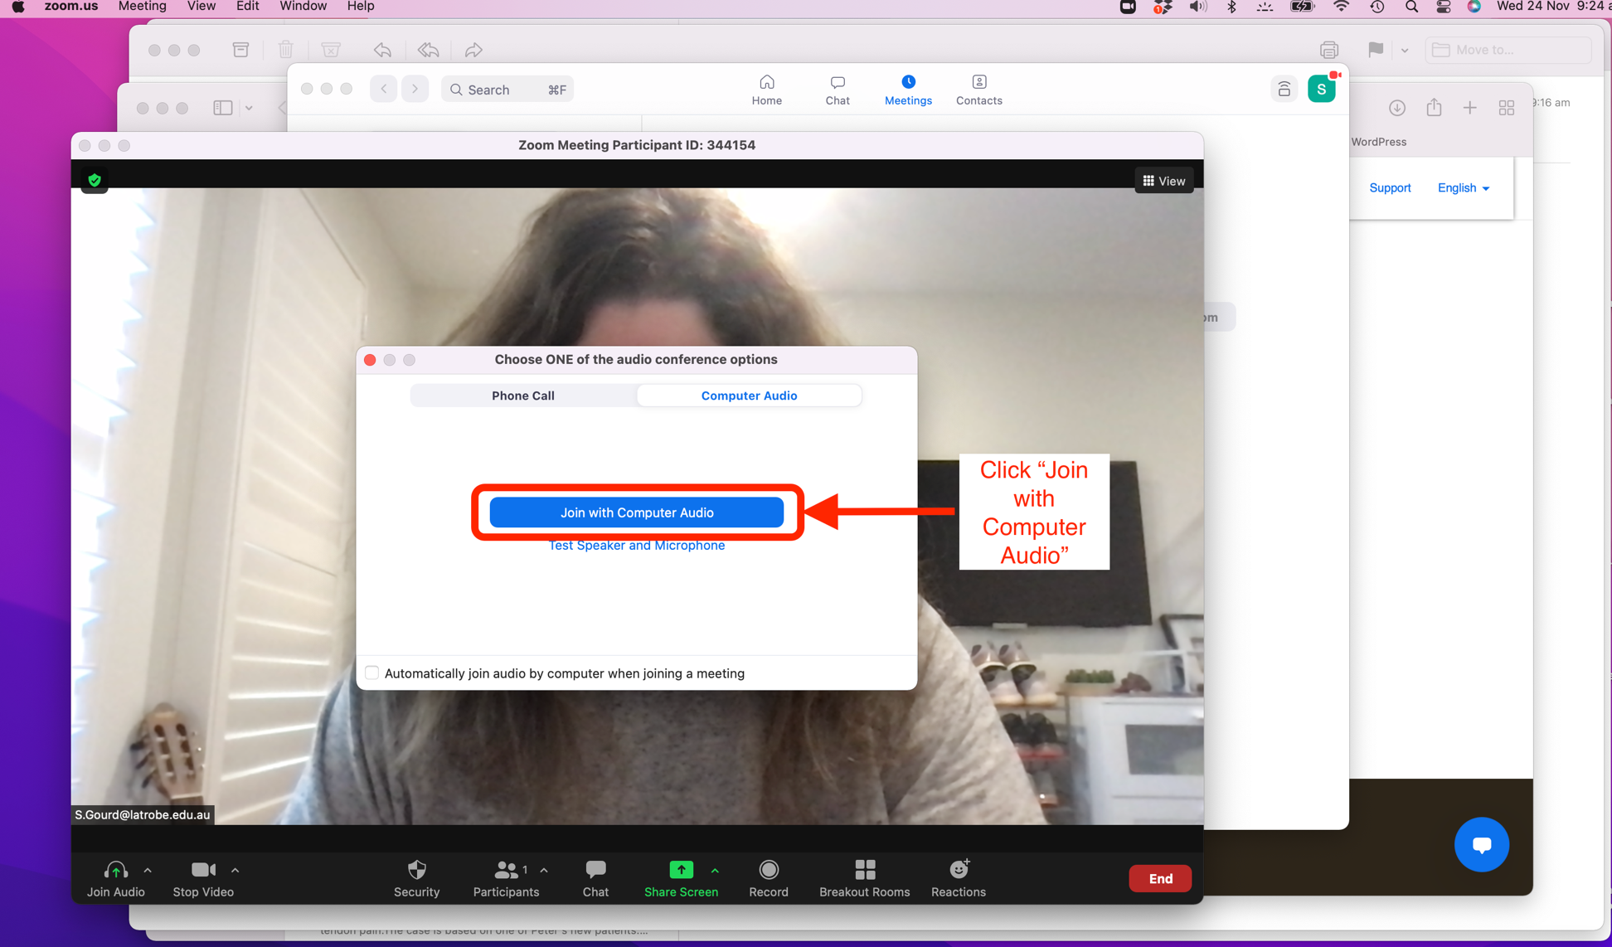

Step 4:
Attend your Zoom telehealth appointment. The features you will need to know about are highlighted in the image below. If you are not confident with Zoom or require assistance, please contact the administration staff at your physiotherapists’ clinic.
